Three-Month Multi-Sprint Roadmap

Roadmap Overview
- Epic 1 – Organization & User Management
- Epic 2 – Content Banking & AI Question Generation
- Epic 3 – Test Creation, Scheduling & Execution
- Epic 4 – Analytics, Results, Leaderboards
- Epic 5 – Subscription, Payments & Usage Tracking

Gantt Chart (3 Months) Example
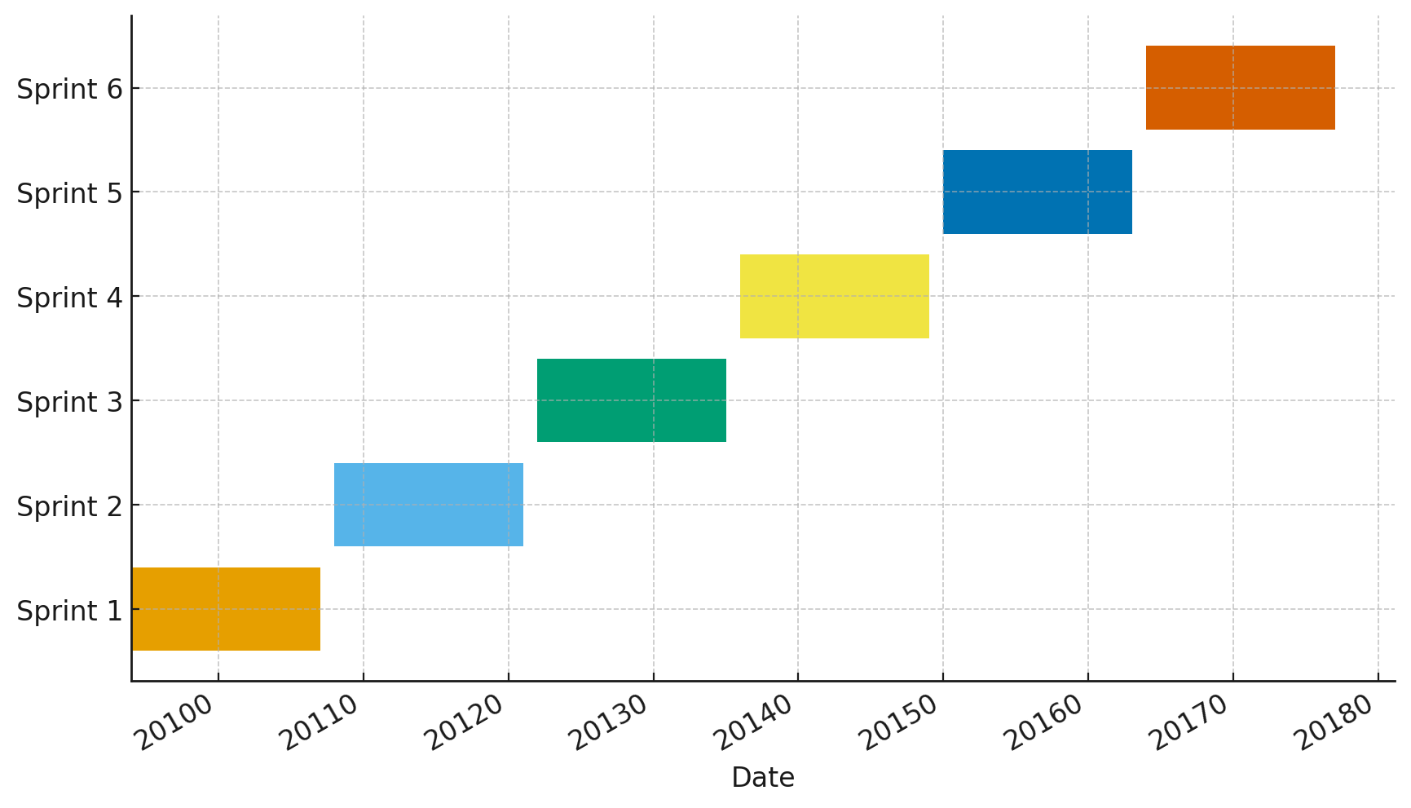

Detailed Sprint Plans (User-Story Level)

Sprint 1: Foundations & Organization Setup
- US-1.1 – Implement Organization creation
- US-1.2 – OrgAdmin / Reviewer role creation
- Setup authentication, RBAC, JWT tokens
- Create initial SuperAdmin dashboard skeleton

Sprint 2: Student Management & Grouping
- US-1.3 – Student enrollment with OrgReg
- US-1.4 – Student group creation & mapping
- UI screens for OrgAdmin-level management

Sprint 3: Question Bank – Creation & AI
- US-2.1 – Manual question entry with LaTeX
- US-2.2 – AI-based question generation
- Split-screen preview interface
- Options table integration and validation

Sprint 4: Reviewer Workflow & Verification
- US-2.3 – Reviewer queue and verification
- Reviewer comments & statuses
- AI quality-check pipeline

Sprint 5: Test Creation & Execution
- US-3.1 – Test builder with topic selection
- US-3.2 – Negative marking & time limits
- Student test-taking interface (Timer + palette)

Sprint 6: Results, Analytics & Subscription
- US-4.1 – Score calculation backend
- US-4.2 – Topic-level analysis
- US-4.3 – Leaderboard
- Subscription plans, counters & payments

